Ball Voyage Game Design Document (GDD)

Ball Voyage

***‘Rolling for a chance to go home’***

**Table of Contents and Team Member Listing**

|  |  |  |
| --- | --- | --- |
| Table of Contents  [1 Game Overview](https://n-xovwktmtjsnaxyc2mwes2xu7pohqedmdm6zjw5q-2lu-script.googleusercontent.com/userCodeAppPanel)  [2 High Concept](https://n-xovwktmtjsnaxyc2mwes2xu7pohqedmdm6zjw5q-2lu-script.googleusercontent.com/userCodeAppPanel) / Genre  [3 Unique Selling Points](https://n-xovwktmtjsnaxyc2mwes2xu7pohqedmdm6zjw5q-2lu-script.googleusercontent.com/userCodeAppPanel)  [4 Platform Minimum Requirements](https://n-xovwktmtjsnaxyc2mwes2xu7pohqedmdm6zjw5q-2lu-script.googleusercontent.com/userCodeAppPanel)  [5 Competitors / Similar Titles](https://n-xovwktmtjsnaxyc2mwes2xu7pohqedmdm6zjw5q-2lu-script.googleusercontent.com/userCodeAppPanel)  [6 Synopsis](https://n-xovwktmtjsnaxyc2mwes2xu7pohqedmdm6zjw5q-2lu-script.googleusercontent.com/userCodeAppPanel)  [7 Game Objectives](https://n-xovwktmtjsnaxyc2mwes2xu7pohqedmdm6zjw5q-2lu-script.googleusercontent.com/userCodeAppPanel)  [8 Game Rules](https://n-xovwktmtjsnaxyc2mwes2xu7pohqedmdm6zjw5q-2lu-script.googleusercontent.com/userCodeAppPanel)  [9 Game Structure](https://n-xovwktmtjsnaxyc2mwes2xu7pohqedmdm6zjw5q-2lu-script.googleusercontent.com/userCodeAppPanel)  [10 Game Play](https://n-xovwktmtjsnaxyc2mwes2xu7pohqedmdm6zjw5q-2lu-script.googleusercontent.com/userCodeAppPanel)  [10.1 Game Controls](https://n-xovwktmtjsnaxyc2mwes2xu7pohqedmdm6zjw5q-2lu-script.googleusercontent.com/userCodeAppPanel)  [10.2 Game Camera](https://n-xovwktmtjsnaxyc2mwes2xu7pohqedmdm6zjw5q-2lu-script.googleusercontent.com/userCodeAppPanel)  [10.2.1 HUD](https://n-xovwktmtjsnaxyc2mwes2xu7pohqedmdm6zjw5q-2lu-script.googleusercontent.com/userCodeAppPanel)  [10.2.2 Maps](https://n-xovwktmtjsnaxyc2mwes2xu7pohqedmdm6zjw5q-2lu-script.googleusercontent.com/userCodeAppPanel)  [11 Players](https://n-xovwktmtjsnaxyc2mwes2xu7pohqedmdm6zjw5q-2lu-script.googleusercontent.com/userCodeAppPanel)  [11.1 Characters](https://n-xovwktmtjsnaxyc2mwes2xu7pohqedmdm6zjw5q-2lu-script.googleusercontent.com/userCodeAppPanel)  [11.2 Metrics](https://n-xovwktmtjsnaxyc2mwes2xu7pohqedmdm6zjw5q-2lu-script.googleusercontent.com/userCodeAppPanel)  [11.3 States](https://n-xovwktmtjsnaxyc2mwes2xu7pohqedmdm6zjw5q-2lu-script.googleusercontent.com/userCodeAppPanel)  [11.4 Weapons](https://n-xovwktmtjsnaxyc2mwes2xu7pohqedmdm6zjw5q-2lu-script.googleusercontent.com/userCodeAppPanel)  [12 Player Line-up](https://n-xovwktmtjsnaxyc2mwes2xu7pohqedmdm6zjw5q-2lu-script.googleusercontent.com/userCodeAppPanel)  [13 NPC](https://n-xovwktmtjsnaxyc2mwes2xu7pohqedmdm6zjw5q-2lu-script.googleusercontent.com/userCodeAppPanel)  [13.1 Enemies](https://n-xovwktmtjsnaxyc2mwes2xu7pohqedmdm6zjw5q-2lu-script.googleusercontent.com/userCodeAppPanel)  [13.1.1 Enemy States](https://n-xovwktmtjsnaxyc2mwes2xu7pohqedmdm6zjw5q-2lu-script.googleusercontent.com/userCodeAppPanel)  [13.1.2 Enemy Spawn Points](https://n-xovwktmtjsnaxyc2mwes2xu7pohqedmdm6zjw5q-2lu-script.googleusercontent.com/userCodeAppPanel)  [13.2 Allies / Companions](https://n-xovwktmtjsnaxyc2mwes2xu7pohqedmdm6zjw5q-2lu-script.googleusercontent.com/userCodeAppPanel)  [13.2.1 Ally States](https://n-xovwktmtjsnaxyc2mwes2xu7pohqedmdm6zjw5q-2lu-script.googleusercontent.com/userCodeAppPanel)  [13.2.2 Ally Spawn Points](https://n-xovwktmtjsnaxyc2mwes2xu7pohqedmdm6zjw5q-2lu-script.googleusercontent.com/userCodeAppPanel)  [14 Art](https://n-xovwktmtjsnaxyc2mwes2xu7pohqedmdm6zjw5q-2lu-script.googleusercontent.com/userCodeAppPanel)  [14.1 Setting](https://n-xovwktmtjsnaxyc2mwes2xu7pohqedmdm6zjw5q-2lu-script.googleusercontent.com/userCodeAppPanel)  [14.2 Level Design](https://n-xovwktmtjsnaxyc2mwes2xu7pohqedmdm6zjw5q-2lu-script.googleusercontent.com/userCodeAppPanel)  [14.3 Audio](https://n-xovwktmtjsnaxyc2mwes2xu7pohqedmdm6zjw5q-2lu-script.googleusercontent.com/userCodeAppPanel)  [15 Procedurally Generated Content](https://n-xovwktmtjsnaxyc2mwes2xu7pohqedmdm6zjw5q-2lu-script.googleusercontent.com/userCodeAppPanel)  [15.1 Environment](https://n-xovwktmtjsnaxyc2mwes2xu7pohqedmdm6zjw5q-2lu-script.googleusercontent.com/userCodeAppPanel)  [15.2 Levels](https://n-xovwktmtjsnaxyc2mwes2xu7pohqedmdm6zjw5q-2lu-script.googleusercontent.com/userCodeAppPanel)  [15.3 Artificial Intelligence NPC](https://n-xovwktmtjsnaxyc2mwes2xu7pohqedmdm6zjw5q-2lu-script.googleusercontent.com/userCodeAppPanel)  [15.4 Visual Arts](https://n-xovwktmtjsnaxyc2mwes2xu7pohqedmdm6zjw5q-2lu-script.googleusercontent.com/userCodeAppPanel)  [15.5 Audio](https://n-xovwktmtjsnaxyc2mwes2xu7pohqedmdm6zjw5q-2lu-script.googleusercontent.com/userCodeAppPanel)  [15.6 Minimum Viable Product (MPV)](https://n-xovwktmtjsnaxyc2mwes2xu7pohqedmdm6zjw5q-2lu-script.googleusercontent.com/userCodeAppPanel)  [16 Wish List](https://n-xovwktmtjsnaxyc2mwes2xu7pohqedmdm6zjw5q-2lu-script.googleusercontent.com/userCodeAppPanel)  17 Bibliography   |  | | --- | |  | | Game Development Team Members    PRODUCER  Taylor    PRODUCTION MANAGER  Taylor    PRODUCTION COORDINATOR  Ethian  GAME DESIGNERS  Taylor, Ethian  SYSTEMS/IT COORDINATOR  Taylor  PROGRAMMERS  Ethian, Taylor  TECHNICAL ARTISTS  Ethian  AUDIO ENGINEERS  Ethian  UX TESTERS  Taylor, Ethian |

|  |
| --- |
|  |

# 1 Game Overview

Title: Ball Voyage

Platform: PC

Genre: Platformer/Action

Rating: (10+) ESRB

Target: Casual gamer (aging from 9 - 20)

Release date: May 4th, 2020

Publisher: Round Studios

Ball Voyage is a 3D casual platformer game where the player is a rolling ball that must evade obstacles to reach his home. The player must evade all the enemies, they cannot jump them (this adds a layer of difficulty), and they only have one life per level otherwise the level restarts. The player wins once they go through the level unscathed.

# 2 High Concept / Genre

Ball Voyage sets the player in a tunnel where they must avoid the obstacles to arrive home. The player cannot touch any of the obstacles otherwise the ball deflates, and the player can try again. If the player reaches the end, the ball will return home and you win. Also, the ball is constantly rolling.

# 3 Unique Selling Points

* 1 life per level (high difficulty)
* Unique gameplay

# 4 Platform Minimum Requirements

OS: Windows 10

Graphics card: RTX 1070

# 5 Competitors / Similar Titles

Our group likes the game rolling sky, so we decided to make a game like it. Instead of making it for a mobile game we decided on making it for pc because we all mostly play on pc.

# 6 Synopsis

You are a ball that wants to go back home to do that you choose the quickest path. The path of obstacles. This path can teleport you to wherever they want to go if they make it to the end.

# 7 Game Objectives

The objective of the game is for the player to make it through the game while evading all the obstacles. At the end of the games, the player reaches their destination and win.

# 8 Game Rules

The player must go through the game without getting hurt, otherwise the player will need to retry. You may move left or right to avoid the obstacles, but you will be rolling constantly so you cannot speed up or slow down. And the ball cannot jump.

# 9 Game Structure

Main Menu

Losing screen

You win!

Credits

Gameplay

Player can choose to go back to the main menu or play again

If player completes the game

If player gets hurt

# 10 Game Play

## 10.1 Game Controls

A = Left

D = Right

## 10.2 Game Camera

The camera focuses and trails the player when it moves. The camera is above the player and the camera can see the obstacles ahead clearly and it moves at the same speed as the player.

### 10.2.1 HUD

None.

### 10.2.2 Maps

No maps will be included.

# 11 Players

## 11.1 Characters

The main character is a blue ball.

## 11.2 Metrics

Life: 1 hit

Speed: 175

## 11.3 States

The player is constantly rolling.

## 11.4 Weapons

No weapons are in this game.

# 12 Player Line-up

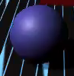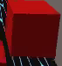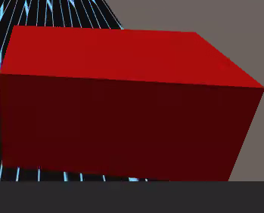

# 13 NPC

## 13.1 Enemies

Enemies are obstacles (red cubes or rectangular prisms as seen above).

### 13.1.1 Enemy States

They do not move but vary in size.

### 13.1.2 Enemy Spawn Points

Carefully placed throughout the game.

## 13.2 Allies / Companions

### Not applicable

# 14 Art

## 14.1 Setting

An open rectangular prism with Tron like design.

## 

## 14.2 Level Design

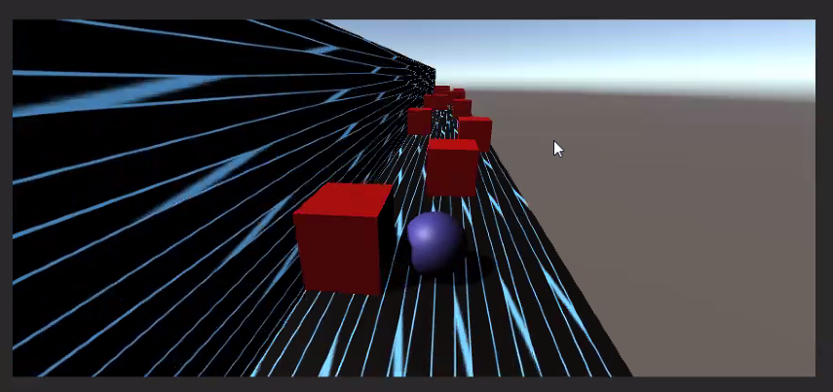

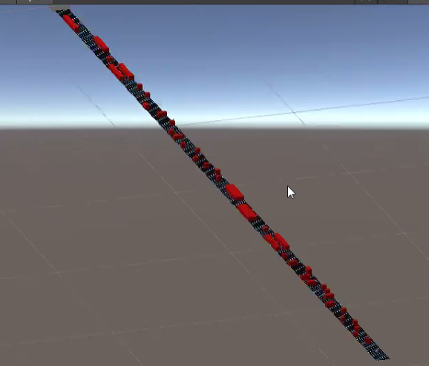

The whole game layout. This includes large obstacles and small obstacles.

## 

## The blue box is the finish line and it will change the scene to the win scene.

## 14.3 Audio

Menu Music: Dust the feelings (plays in the main menu and other menu related scenes)

Game Music: The Great Dance (plays when you start the game)

Lose music: Player losing or falling (Plays on losing scene)

You Won music: Bonus earned in video game (plays in the winning scene)

# 15 Procedurally Generated Content

## 15.1 Environment

Same as 14.1

## 15.2 Levels

Three levels with same level design except number of enemies.

## 15.3 Artificial Intelligence NPC

Same as 13.1

## 15.4 Visual Arts

Sane as 14.1

## 15.5 Audio

Same as 14.3

## 15.6 Minimum Viable Product (MPV)

* Built for PC
* No animation
* One level

# 16 Wish List

* Add more animation
* More level design variety
* More level
* Add different obstacles

## 17 Bibliography

Menu Background: T. (2019, August 29). Retrieved from https://pixabay.com/illustrations/tunnel-wallpaper-background-scifi-4427835/

Game and menu music: Royalty Free Music. (n.d.). Retrieved from https://www.hooksounds.com/royalty-free-music/?page=2

Game font: Linecreative. (2020, November 19). Bord Font: Linecreative. Retrieved from https://www.fontspace.com/bord-font-f46152

Collision Tutorial: Destroy OTHER objects on Collision Unity. (n.d.). Retrieved from https://answers.unity.com/questions/1077612/destroy-other-objects-on-collision-unity.html

Constant forward camera and ball movement: Constant movement of a game object along x axis. (n.d.). Retrieved from https://answers.unity.com/questions/938963/constant-movement-of-a-game-object-along-x-axis.html

Check collided object’s name to figure out if game is complete or lost: Check collided objects name. (n.d.). Retrieved from https://answers.unity.com/questions/591476/check-collided-

objects-name.html

How to move ball with a and d: How to move the Character using WASD. (n.d.). Retrieved from https://answers.unity.com/questions/1373810/how-to-move-the-character-using-wasd.html

Losing and winning music: Download Free Game Sound Effects. (n.d.). Retrieved from https://mixkit.co/free-sound-effects/game/

Smiley and sad face: Ethian Chiu